What You Need
A mobile device capable of sending text messages.
The barcode number from your Library card (ten digits, Dxxxxxxxxx), and the PIN for your library account.
Signing Up
1. Open your Messaging app and create a new Text Message to 844-225-9458.
2. Add the following text to your message: SIGNUP+PatronBarcode+PIN
The Patron Barcode is your library card # starting with D.
The PIN is the password used for RSAcat. Ask your library if you don’t know it.
Example: SIGNUP+D008675309+ab12
3. Add 844-225-9458to your contact list as Shoutbomb or Library Texts so you recognize the messages in the future.
Alternatively, you can just text SIGNUP to the number above and Shoutbomb will send additional texts for your card # and PIN to finish the signup process.
Once your Shoutbomb registration is complete, you will automatically get text notices around 9am about holds, items due in the next 3 days, overdues and more. Texts are only sent when activity in your library account triggers them.
For More Information
Contact: +++Name here+++
XXXXX Public Library
[Insert contact info and website.]
Other Library Apps
RSAcat Mobile Catalog
Use the library on the go
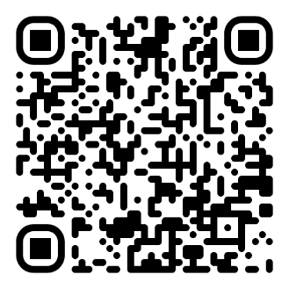
The Palace Project
eBooks and Audiobooks

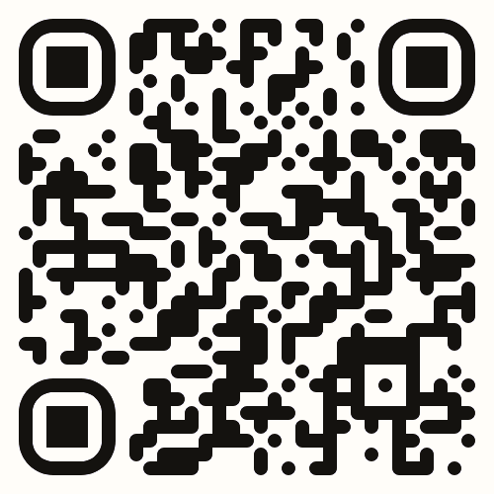

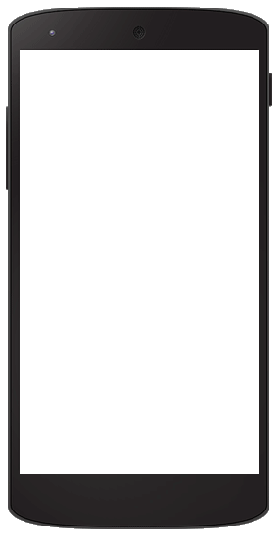

RSAcat
Text Message
Service

Get Library notices
and renew items
via text message
from ShoutBomb!

Shoutbomb Text Message Alerts
Your Library’s Shoutbomb text messages allow you to use your mobile phone to:
Receive text notices about: holds that are available, items that are due soon, overdue items, and fines.
Send a text to renew a loan. If the item is eligible for renewal, it will renew. If the item is not eligible for renewal, it will fail. Either result will be reported by text message.
The Library does not charge a fee for this service, but your mobile plan’s regular text-messaging rates apply.
Basic Keyword Commands
You can text the following commands to 844-225-9458; follow any instructions that are texted back to you:
MYBOOKS
Sends a snapshot of the status of all your items including unfilled holds and fees.
ADDCARD
Register an additional Library card for text messages on your phone.
DROPCARD
Cancel text notices for a card added with ADDCARD.
TEST
Test your connection to Shoutbomb.
SWITCHPHONE
If you change your phone number/mobile carrier, this text will update your profile.
ZIPCODE #####
(Substitute your 5-digit zip code for #####.) Add your zip code to match your phone with your home library. For future features.
IOWEU
Returns information about your current fee amount. If you have multiple cards registered, you will receive information about each card.
TEST
Test your connection to Shoutbomb.
HELP
Get information about all Shoutbomb commands.
RESEND
Get the last message from Shoutbomb again.
Quit
Delete your mobile device from the Shoutbomb notice service.
Replying to Notices
Your account notices will prompt you to respond with optional commands, including:
HL
Get a list of holds that are ready for pickup. (Holds notice.)
RL
Get a list of items you can renew. (Courtesy notice.)
RA
Renew all eligible items. (Courtesy notice.)
OL
Get a list of overdue items. (Overdue notice.)
Message Settings
To view and change your Shoutbomb message settings, text these commands:
NOTICES
See your current on/off status for each type of notice. Do this first!
HOLDS
Toggles your holds notices off/on.
RENEW
Toggles your courtesy notices (about items that are due soon) off/on.
OVERDUE
Toggles your overdue notices off/on.
FEES
Toggles your notices about fines and fees off/on.

