**What You Need:**

A mobile device capable of sending text messages.

The barcode number from your Library card (ten digits, Dxxxxxxxxx), and the PIN for your library account.

**Signing Up:**

1. Open your Messaging app and create a new Text Message to **844-225-9458**.

2. Add the following text to your message: **SIGNUP+*PatronBarcode+PIN***

The *Patron Barcode* is your library card # starting with D.

The *PIN* is the password used for RSAcat. Ask your library if you don’t know it.

Example: SIGNUP+D008675309+ab12

3. Add **844-225-9458**to your contact list as Shoutbomb or Library Texts so you recognize the messages in the future.

**Alternatively,** you can just text **SIGNUP** to the number above and Shoutbomb will send additional texts for your card # and PIN to finish the signup process.

Once your Shoutbomb registration is complete, you will automatically get text notices around 9am about holds, items due in the next 3 days, overdues and more. Texts are only sent when activity in your library account triggers them.

**For More Information**

Contact: +++Name here+++

XXXXX Public Library  
[Insert contact info and website.]

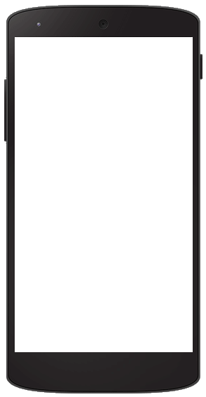

RSAcat  
Text Message

Service

Get Library notices

and renew items

via text message

from ShoutBomb!

**Shoutbomb Text Message Alerts**

Your Library’s Shoutbomb text messages allow you to use your mobile phone to:

🡺 Receive text notices about: holds that are available, items that are due soon, overdue items, and fines.

🡺 Send a text to renew a loan. If the item is eligible for renewal, it will renew. If the item is not eligible for renewal, it will fail. Either result will be reported by text message.

The Library does not charge a fee for this service, but your mobile plan’s regular text-messaging rates apply.

**Basic Keyword Commands**

You can text the following commands to **844-225-9458;** follow any instructions that are texted back to you:

**MYBOOKS**  
Sends a snapshot of the status of all your items including unfilled holds and fees.

**ADDCARD**  
Register an additional Library card for text messages on your phone.

**DROPCARD**  
Cancel text notices for a card added with ADDCARD.

**TEST**  
Test your connection to Shoutbomb.

**SWITCHPHONE**  
If you change your phone number/mobile carrier, this text will update your profile.

**ZIPCODE #####**  
(Substitute your 5-digit zip code for #####.) Add your zip code to match your phone with your home library. For future features.

**IOWEU**Returns information about your current fee amount. If you have multiple cards registered, you will receive information about each card.

**TEST**  
Test your connection to Shoutbomb.

**HELP**  
Get information about all Shoutbomb commands.

**RESEND**  
Get the last message from Shoutbomb again.

**Quit**  
Delete your mobile device from the Shoutbomb notice service.

**Replying to Notices**

Your account notices will prompt you to respond with optional commands, including:

**HL**  
Get a list of holds that are ready for pickup. (Holds notice.)

**RL**  
Get a list of items you can renew. (Courtesy notice.)

**RA**  
Renew all eligible items. (Courtesy notice.)

**OL**  
Get a list of overdue items. (Overdue notice.)

**Message Settings**

To view and change your Shoutbomb message settings, text these commands:

**NOTICES**  
See your current on/off status for each type of notice. Do this first!

**HOLDS**  
Toggles your holds notices off/on.

**RENEW**  
Toggles your courtesy notices (about items that are due soon) off/on.

**OVERDUE**  
Toggles your overdue notices off/on.

**FEES**  
Toggles your notices about fines and fees off/on.