**The RSAcat catalog makes local libraries’ collections more visible and accessible to patrons across our central Illinois service area.**

RSAcat allows you to:

* Search for items in your library and in other (or all) libraries in the region.
* Place holds on items to have them sent to the pickup library of your choice.
* Manage your checkouts, holds, fines, and lists from your catalog account
* Browse new items in the collection using the “carousel” on the catalog home page
* Use the “Limit Search Results” options to quickly and easily edit your search from the results page, eliminating the need to backtrack or browse pages of irrelevant search results
* Copy to your notes or email item information to yourself (or a friend) and keep track of what items that interest you.
* Bookmark searches so that you’re alerted when new items meeting your search criteria are added to the collection

*Read on to learn more!*

**Need more assistance with RSAcat?**

No problem! There are several sources for more guidance, including:

1. **RSAcat homepage**
   * The bulk of the homepage is currently devoted to “Tips for Searching and Using RSAcat”
   * RSAcat Help link – included in the box of links in the upper left section of the catalog homepage, just under the quick search bar
2. ***Your library staff*** is always happy to help! You can even email questions to your library staff directly from the catalog homepage using the “Contact Your Library” link. This link is included in the box of links in the upper left corner of the homepage.

***Your Library Card #:***

***Your PIN/password:***

***Contact your library:***



**RSAcat Library Catalog**

The RSAcat library catalog helps users take advantage of the millions of items from 135 libraries and their branches in the regional Resource Sharing Alliance (RSA).

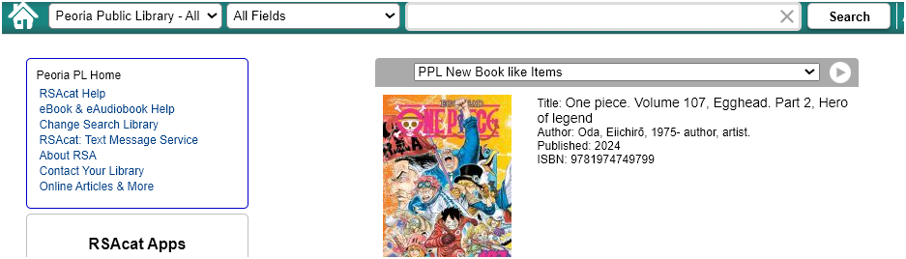

**To search the RSAcat catalog:**

1. Enter a search term(s) into the box near the top of the page. In RSAcat, this quick search box is available on *every* page (rather than just the homepage).
2. If you like, you can also use the dropdown menus to the left of the box to specify a library or group of libraries to search, as well as the type of search term you’ve entered (title, author, ISBN, etc.).

**Additional features available on the library catalog homepage:**

* A link to the “Advanced Search,” with more powerful and precise searching options
* A customizable carousel displaying new items in your library’s collection
* A number of useful links in the left sidebar, including the RSAcat Help pages, info on searching free online articles, and instructions on signing up for our text notification service!
* A list of RSA-related apps available for you to download to your mobile devices

[Insert your company information in place of the sample text.

Click the Office button, and then click Save As. Click Document Template in the Save as dialog box (the file name extension should change from .docx to .dotx).

Next time you want to use it, click the Office button, and then click New. Click My Templates. Double-click this template to base another brochure on it.]

[Working with breaks]

[Using the Break command, you can insert manual page breaks, column breaks, and section breaks. To insert a break, click Breaks on the Page Layout tab, and then select an option.]

If your simple search returns multiple items, you will see a **search results page**:

From here, you have many options, including:

You have many features to explore from the search results page, including:

* **Limit Search Results** menu in the left margin narrow your results, making it easier for you to find just what you need. Limits gives you the power of an advanced search by allowing you to filter results after the fact.
* **Use Search Tabs** to change how your search is limited. Try it if you only want to see (or exclude) eBook titles, or want to search RSA-wide.
* Using the **Actions:** menu to
  + Place holds (one or many)
  + Add item(s) to a list
  + Email or print item details for later referral
* **Adjust how the search results are sorted**, from most relevant first to newest or oldest first, or alphabetical by title or author

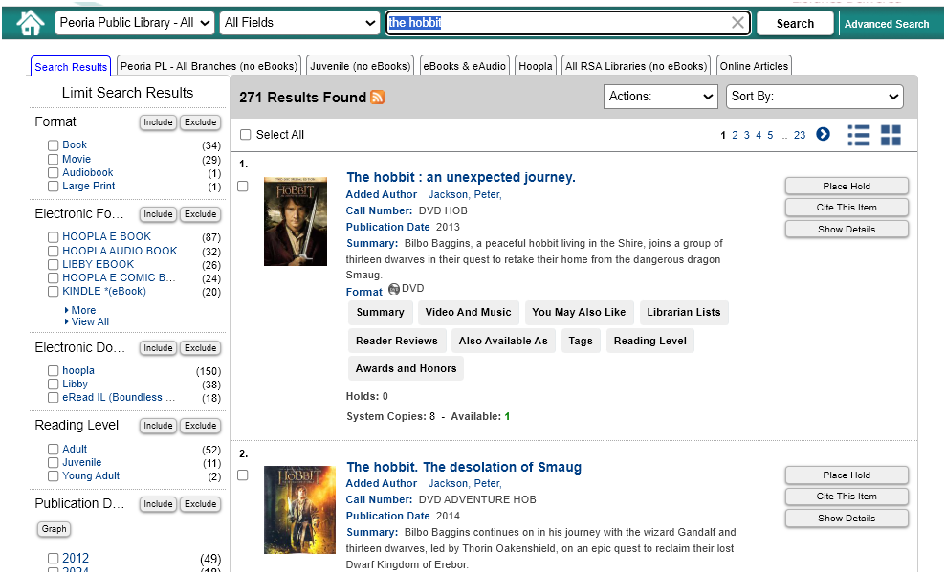

Click the title, cover or on the “Show Details” button next to the item information on the search results page to go to the **item details page**. Here, find more information and info about availability on the title.

In addition to providing more details about the item (plot summary, availability in RSA libraries, etc.), the item details page also offers useful features and options, like:

* Placing a hold on the item
* Exporting item details to a temporary or saved list; email account; or printer
* Lists of similar items, so that once you find something you need, you can easily find others like it
* The **More Information about Title tab** allows you to see similar titles, reading levels, read reviews, and more.

If your library owns a copy of the title on this page, it will appear at the top of the list.

