

**RSAcat Online Catalog**

**My Library Account**

Access **your online library account** from the top of any RSAcat page using your library card number and PIN. From your Account, you can **manage your checkouts and renewals, holds, fines, and lists**.

**Searching the Catalog**

Quickly search RSAcat from the **simple search box near the top of every catalog page**. Use the dropdown menus by the search box to limit your search to a particular library branch (if applicable) or to a certain item type (book, e-book, movie, etc.), or to specific search fields (title, author, or subject.)

Having trouble finding that you want with a simple search? Try a more customized **Advanced Search**, where you can specify exact search phrases or limit to certain formats, languages, or libraries.

Your Library’s Link: alsi.sdp.sirsi.net/client/en_US/**Replace**/

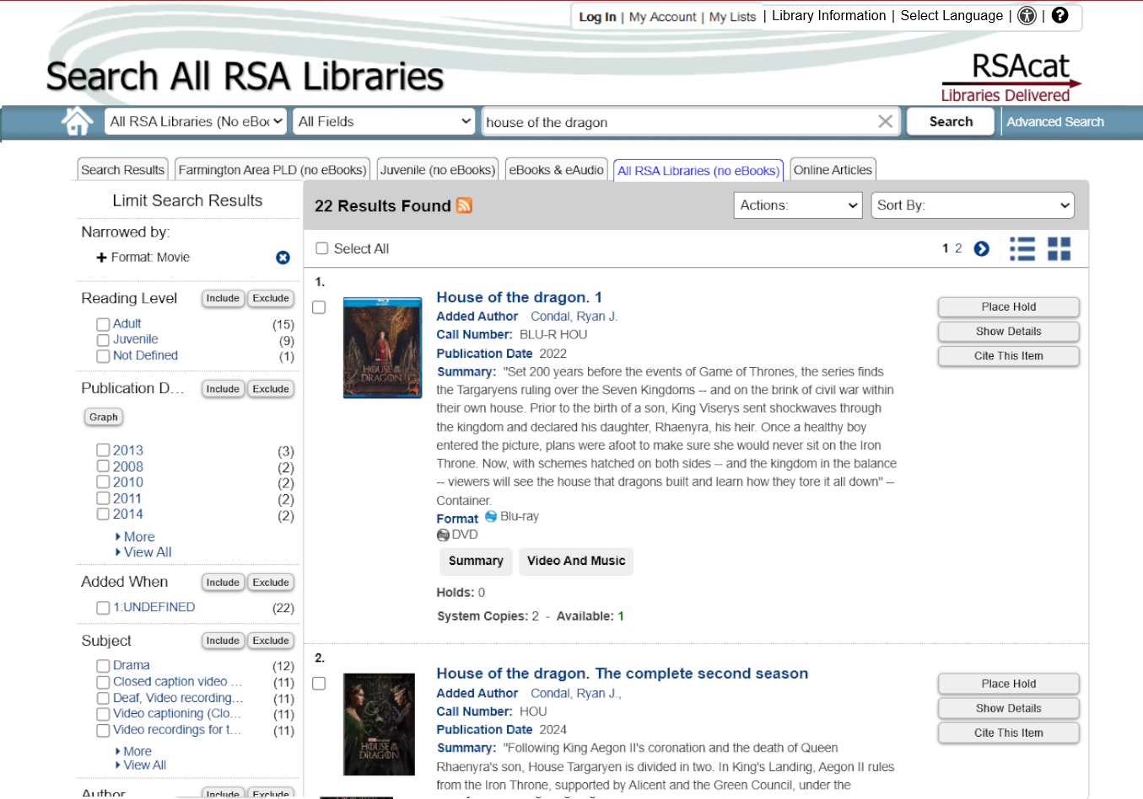

Need more assistance? Visit the extensive **RSAcat Help** link on the left side of the catalog homepage. Help guides are available by clicking the question mark icon “?” in the upper right of each page. Also in the top right, find contact info including hours, email, and phone number for your library in the **Library Information** link.

**Limit Search Results**

If a quick search returns too many unwanted results, you can “**Limit Search Results” using the options in the left margin**. These limiting options can help you narrow your search to specific formats, subjects, publication dates, and more – making it easier to find just what you’re looking for without having to go back and edit your search. Just click on the word(s) or fill in the check box next to the detail you’d like to focus on and click the “Include” button. Your search results will then update to include only items meeting the newly added criteria.

In this example, we’ve limited a simple search for *House of the Dragon* to zero in on the most TV show movie formats (DVD/Blu-ray), rather than the book, and other related material that populated the list of 100+ items in the original results.

**Features Available**

***Reserve an item (place on hold)***

***Place holds directly from the search page***

Simply click on the “Place Hold” button next to the item you want. Or to place multiple holds at once, just fill in the check boxes next to the items you would like to put on hold, then select “Place Hold(s)” from the “Actions:” dropdown menu . You can also still place individual holds from the item record pages, like with the previous catalog interface.

***Print or email item information for easy retrieval***

Just like with holds, you can fill in the check boxes next to items you would like to print out or have sent to you, and then select the appropriate option from the “Actions:” menu. “Cite This Item” may be useful to students and researchers -- it will open a pop-up window from which you have to click a **”** button to get your citation of choice. From an item’s detail page you can also copy a Permalink URL.

***Customizing the way search results are sorted***. You can sort by relevance, publication date (newest or oldest first), or alphabetically by title or author using the “Sort By” dropdown menu. ***Search Tabs*** along the top can display/hide eBook results or free, full-text articles.